­­



Submitted to:

Sir.Asim Zaman

***BS-ARTIFICIAL INTELLIGENCE***

Title: Assignment 1

IICT

Umair Mehmood

ID#NUML-F22-36855



National University of Modern Languages

SOFTWARE DESIGN & ARCH

What is OSI Model?

OSI Model:

OSI (Open Systems Interconnection) could be a reference model for the way applications communicate over a network. This model focuses on providing a visible style of however every communications layer is constructed on prime of the opposite. OSI Model describes seven layers that laptop systems use to speak over a network. it had been the primary normal model for network communication, adopted by all major laptop and telecommunication firms within the early Nineteen Eighties.

OSI Model Layers:

The OSI Model split into seven abstraction layers:

1. Physical layer.
2. Data Link layer.
3. Network layer.
4. Transport layer.
5. Session layer.
6. Presentation layer.
7. Application layer.

Graphical Representation

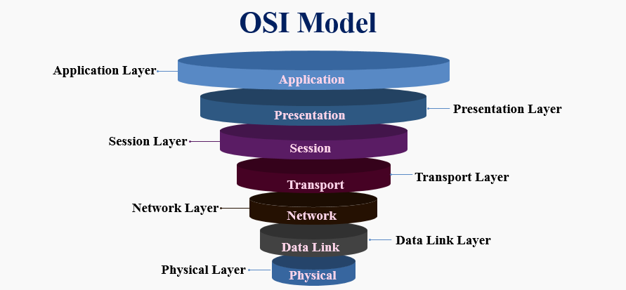

How it uses layered design architecture for its functioning?

* OSI model divides the complete task into seven smaller and manageable tasks. every layer is allotted a selected task.
* Each layer is self-contained, so task allotted to every layer will be performed severally.
* The OSI model is split into 2 layers: higher layers and lower layers.
* The higher layer of the OSI model primarily deals with the applying connected problems, and that they square measure enforced solely within the software package each the tip user and also the application layer act with the software package applications. Associate in Nursing higher layer refers to the layer simply higher than another layer.
* The lower layer of the OSI model deals with the information transport problems. the information link layer and also the physical layer square measure enforced in hardware and software package. The physical layer is principally answerable for putting the knowledge on the physical medium.

